ANFAO: THE ITALIAN EYEWEAR INDUSTRY
BETWEEN IDENTITY AND GLOBAL MARKETS
Targeted, full-spectrum initiatives to support the industry and ITS businesses
Milano, 11 December 2025 – The General Meeting of ANFAO – Italian Optical Goods Manufacturers’ Association – was held at Palazzo Crepadona in Belluno.
The meeting focused on “Italian eyewear at the intersection of identity and global markets”. ANFAO President Lorraine Berton, together with the Executive Board and the Association’s members, reviewed the year’s activities and outlined the initiatives planned for 2026.
“The challenge we are facing is to maintain a balanced approach between staying true to our identity, to the roots of an expertise that is unique in the world, and operating within increasingly competitive, demanding and fast-changing global markets,” stated President Berton. “It is a delicate balance, but this is precisely where the strength of our sector is measured – in its ability to combine tradition and innovation, values and vision, our territory and the world.”
ANFAO, HOME OF EYEWEAR COMPANIES
In 2025, ANFAO further strengthened its leadership role in the sector through high-profile projects organized around internationalization, sustainability, innovation and digitalization, inclusion, culture, training, and the medical profession. Noteworthy among these are the key initiatives in 2025 and those planned for 2026:
- INTERNATIONALIZATION: remains one of the strategic priorities, the key to staying competitive, expanding markets, and consolidating the Italian eyewear industry’s leadership worldwide. “In this regard, we have achieved an important milestone – the strengthening of the ITA (Italian Trade Agency) plan specific to our sector will allow us to expand the promotion of Made in Italy abroad, supporting Italian companies and opening up new opportunities in emerging markets. This is an achievement that strengthens the entire system and shows just how effective teamwork between ANFAO, institutions, and companies can be," declared the President. With reference to the second half of the year alone, ANFAO participated in and promoted numerous international initiatives, including the Days of Italian Fashion in the World event in Japan, the United Arab Emirates, Brazil and India; the IEE – Italian Eyewear Exhibition in Paris; the business mission in Brazil; and the Italian group presence at Silmo Istanbul. New international ventures are planned for 2026 in partnership with ITA including, to date, IEE Milano on January 30, with more than 60 Italian companies, IEE New York on March 4 and IEE Paris on September 25.

- SUSTAINABILITY: in collaboration with Deloitte Climate & Sustainability, ANFAO has developed a free training program for SMEs on the topics of sustainability reporting, ESG culture and the integration of environmental, social, and governance principles into business processes. An even broader training program is being developed for 2026, which will include topics such as sustainable supply chain management, incentives for energy transition, and the relationship between banks and businesses with a focus on sustainability. ANFAO is also working to transform CSE Certification into a standard recognized at the European level, working toward its evolution as PCR - Product Category Rules. Finally, a project is being developed to support companies in adopting sustainable, circular business models.

- INNOVATION AND DIGITALIZATION: a new project was introduced that aims to support companies in the digitalization of processes, in the adoption of AI, and in the development of new organizational and production models. The initiative will be presented in detail in the coming months.

- INCLUSION: the Association has created a free "Walk the Talk" course on inclusive behaviors. For the next year, the focus of the project will shift to attracting young talent, creating business ecosystems oriented towards well-being, diversity, and inclusion, and enhancing the sector's attractiveness to younger generations.

- CULTURE: The Lens of Time exhibit at Palazzo Flangini in Venice was a huge success. It can be visited at the M9 Museum in Mestre, in a dedicated corner area, until February 15. The project will also be featured at MIDO 2026, with a spectacular installation in the Pavilion 6 Piazza; next Fall it will be in Rome at Palazzo Piacentini, headquarters of the Ministry of Enterprises and Made in Italy (MIMIT).

- TRAINING: New funding was approved for the Copernico 2.0 Project, created and designed by ABLE-CERTOTTICA together with ANFAO, a natural evolution of the platform that, with AI support, makes it possible to create personalized courses. The Youth Group has also developed export-management training programs, investing in the next generation through high-level educational tools in partnership with LUISS Business School.

- MEDICAL PROFESSION: the Association is committed to promoting dialog between the medical profession and opticians through projects like Eyevolution and the protocol for tele-reporting.

Finally, ANFAO confirms its role as a key institutional player for the Italian eyewear industry by participating on the Confindustria and MIMIT main technical committees. It promotes projects that enhance the "Made in Italy" brand, such as the Terre dell’Occhiale-Eyewear Lands project – a diffused eco-museum developed with the Museo dell’Occhiale – and supports innovation through co-innovation and open-innovation programs.
ExportS AND MARKETS: THE CONCERNS
“The most recent data portray an industry that maintains its strength. Exports are struggling in the United States, but improving elsewhere. In Europe, results are positive in France and Spain and especially strong in Eastern Europe. These signals tell us we are heading in the right direction. We must continue to work together, investing in quality, reputation, and system," remarked President Berton.

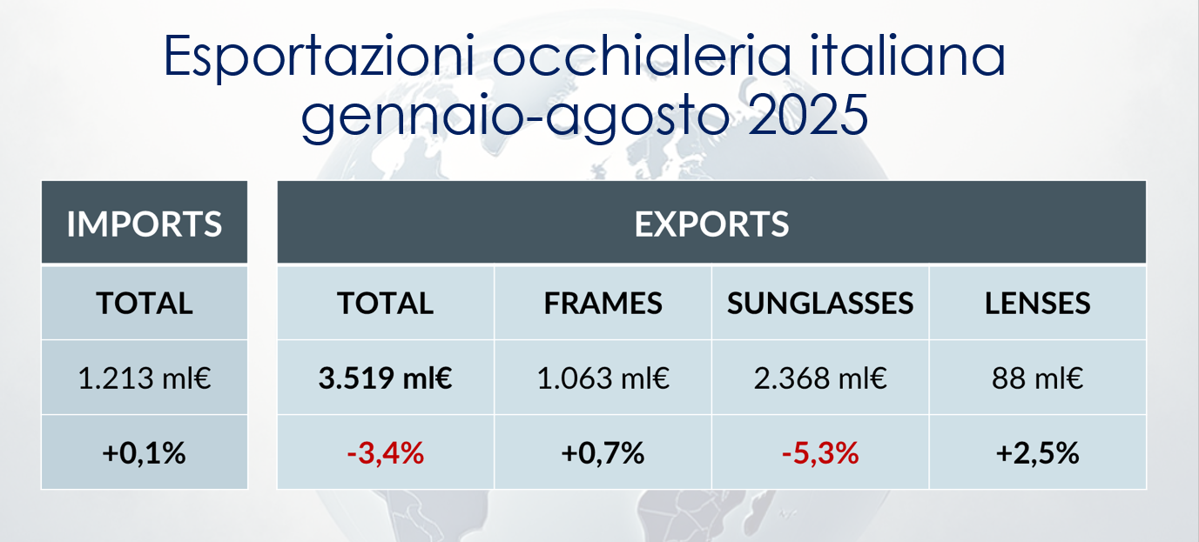
[Italian eyewear exports January-August 2025]

FUTURE INDUSTRY EVENTS
The eyewear system will inaugurate the new year with the 54th edition of MIDO, January 31 to February 2 at Fieramilano Rho. During 2026, there will be numerous initiatives by the Commissione Difesa Vista ETS, including local vision screenings, partnerships with sports federations and prevention activities. In the Fall, September 12-14, DaTE, the independent eyewear show, will be held in Naples, Salone Margherita.

ANFAO Press Office
Carolina Mailander Comunicazione
Paola Masera +39 335 6643677 paola.masera@cmailander.it
Stella Casazza +39 349 3579552 stella.casazza@cmailander.it
Martina Bruno +39 3286222616 martina.bruno@cmailander.it

