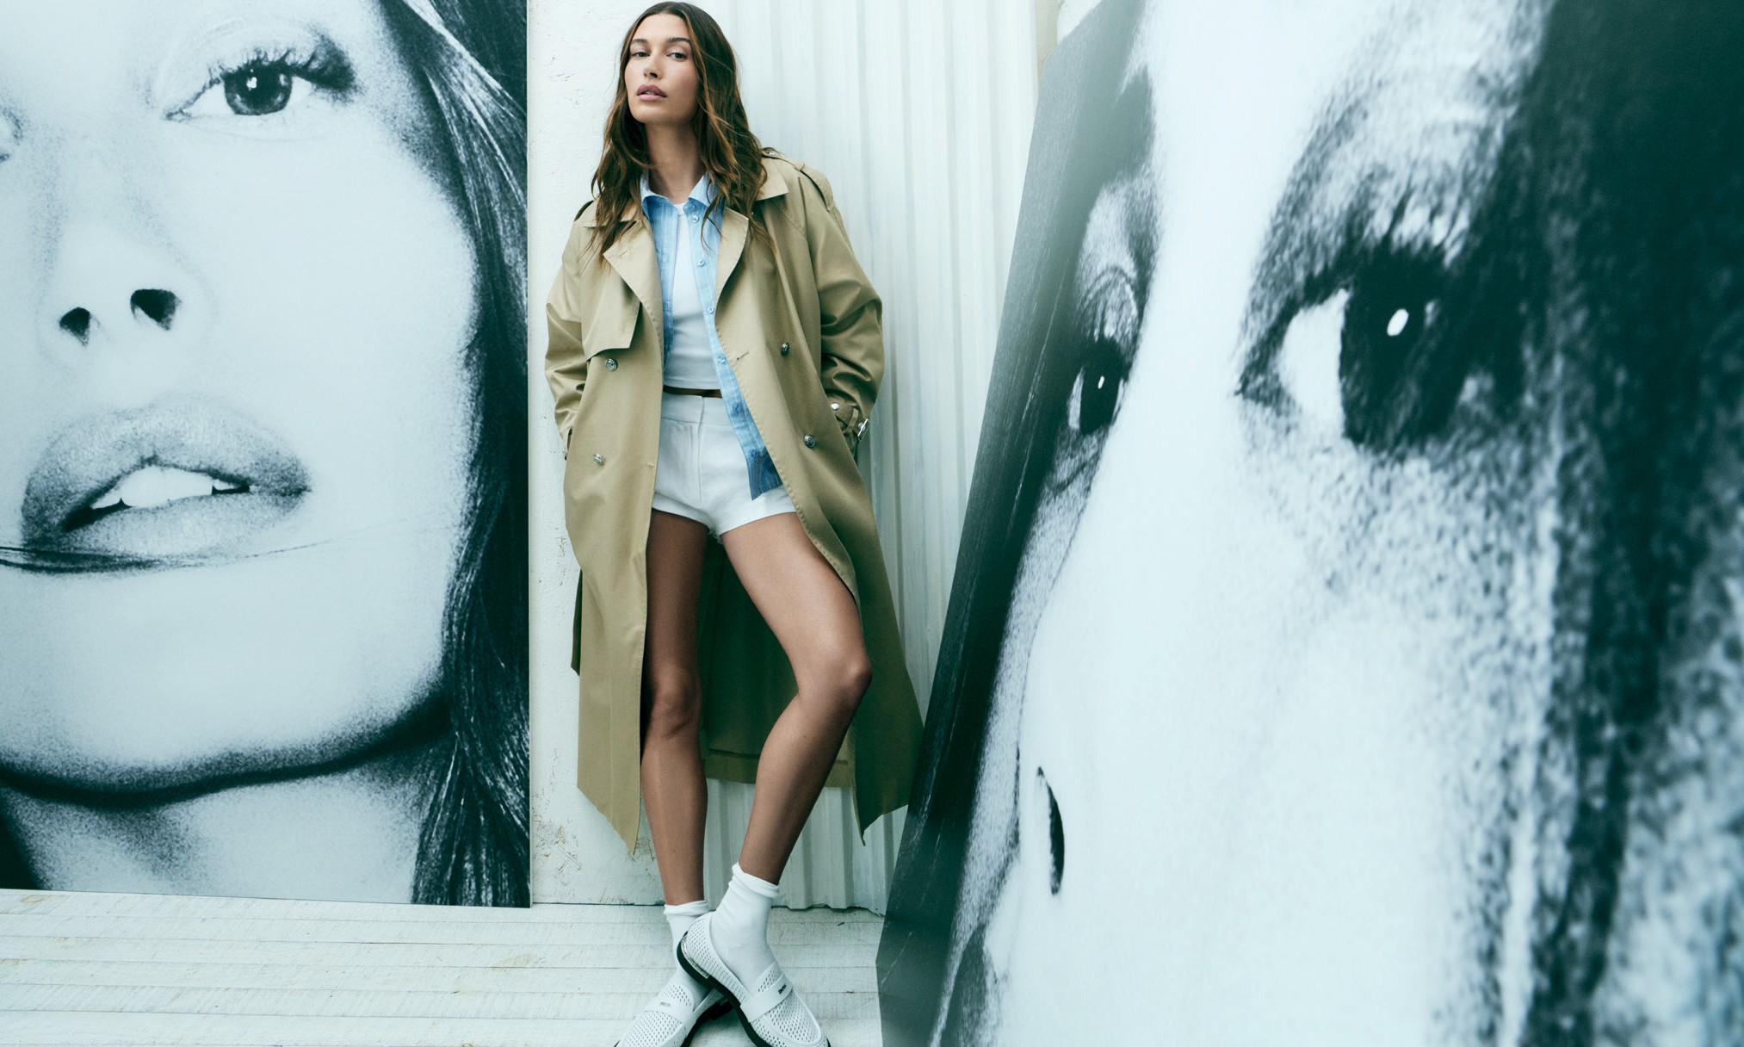

DKNY REVEALS ITS SPRING 2026 CAMPAIGN FEATURING HAILEY BIEBER

New York, New York (February 10, 2026) – The icon is back: Hailey Bieber returns as the global face of DKNY, continuing last season’s breakthrough fashion story with a new, high-
impact campaign. For Spring 2026, the disruptive art scene of downtown New York in the ’60s sets the stage for a fresh spin on the recreation of
an icon. Expanding on fame as an art form, the campaign places Hailey at the center of a black-and-white photo series of herself while wearing looks from the latest collection.
The DKNY Spring 2026 campaign concept takes us into an artist’s loft – the quintessential New York setting for creative encounters and the
free flow of ideas. Hailey appears effortlessly dressed: a trench and denim shirt worn open over layers that sit close to the body; tailored pants and loafers juxtaposed with a bra and oversized top; the “Naked Dress” made famous in Sex and the City, now in black with clear straps and a minidress in a polished pinstripe; relaxed jeans and a blazer that channels a ’90s attitude. And of course, she wears the New York Yankees™ cap in collaboration with DKNY. The brand’s multi-faceted energy pulses throughout. Amidst a
monochromatic palette of black, white, beige and denim, strong eyewear and a signature bag add necessary accents to give each look that distinctive New York edge.
Jeff Goldfarb, EVP of G-III Apparel Group
says, “Hailey Bieber is one of the most influential style leaders today and a natural choice to continue representing DKNY globally. What makes this partnership so successful is how her personal style aligns authentically with the brand. She embodies the energy of DKNY while making the clothes her own.”
With a concept grounded in creativity and reinvention, Spring 2026 elevates what is essential. Hailey’s true style parallels the
brand as it evolves from one season to the next. Together, a statement that is larger-than-life.
Launching today, the campaign and collection will debut globally on @DKNY’s owned social channels, and a robust media mix, leading with social, digital, premium outdoor, print, and influencer partnerships. The collection is available to shop on DKNY.com and in select retailers worldwide.

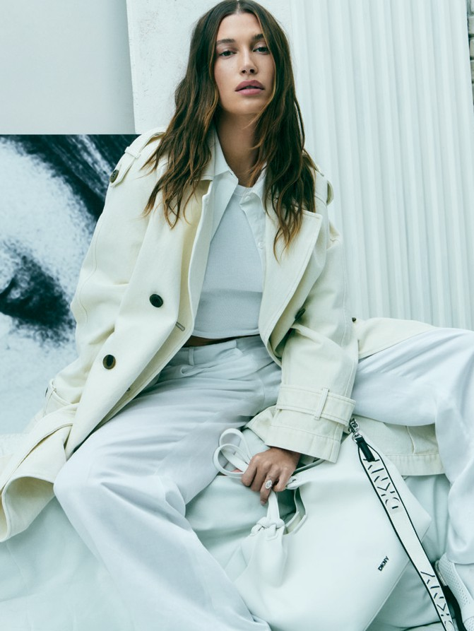

Creative Direction by Trey Laird Photographed by Mikael Jansson Styled by Clare Richardson
Set design by Stefan Beckman Hair by James Pecis
Make-up by Hannah Murray BTS Images by Tyrell Hampton

ABOUT DKNY
Since its inception in 1989, DKNY has been synonymous with New York—inspired by the energy and attitude of the city. Founded on a pair of jeans and the speed of sport, DKNY is utility and purpose—it’s practical and contemporary. Drawing on Donna Karan’s original principle of designing for the woman who never knew where the day would take her, DKNY has transformed into a global lifestyle powerhouse: the dynamic wardrobe of everything you need to live a New York life—wherever that may be. Today, we reimagine and reinvent once again—our love for New York City, serving as both muse and mentor. From stitch to silhouette, we invite the world to explore
new collections where culture, confidence, and the heartbeat of New York converge and become part of a brand that is not just worn—but lived. This is our love letter to the authentic street style and boundless energy that define the very DNA of New York—a narrative that unfolds in a new era of accessibility.

ABOUT G-III APPAREL GROUP, LTD.
G-III Apparel Group, Ltd. (NasdaqGS: GIII) is a global fashion leader with expertise in design, sourcing, distribution, and marketing. The Company owns and licenses a portfolio of more than 30 preeminent brands,
each differentiated by unique brand propositions, product categories, and consumer touchpoints. G-III owns ten iconic brands, including DKNY, Donna Karan, Karl Lagerfeld, and Vilebrequin, and licenses over 20 of the most sought-after names in global fashion, including Calvin Klein, Tommy Hilfiger, Levi’s, Nautica, Halston, Converse, BCBG, French Connection, and major national sports leagues, among others.

FOR MEDIA INQUIRIES, PLEASE CONTACT:

Gabriella Romero | gabriella.romero@g-iii.com

